# ASP.NET Fundamentals Exam – 22 October 2022

# Book Library

Exam problems for the ["ASP.NET Core Fundamentals" course @ SoftUni](https://softuni.bg/trainings/3853/asp-net-fundamentals-september-2022). Submit your solutions in the **SoftUni judge** system (delete all "**bin**"/"**obj**" folders).

**BookLibrary** is an online platform that is used to create and collect books.

## Technological Requirements and Overview

* Use the provided skeleton – **Library_Slekenton_6.0** All of the needed packages have been installed.

**The Technological Requirements are ABSOLUTE. If you do not follow them, you will NOT be scored for other Requirements.**

The provided skeleton consists of:

* **Areas/Identity/Pages/Account** – You are free to choose whether you'd like to use scaffolded identity or not
* **Controllers** – you should implement the controllers here
* **Data** – you should hold the entities here
* **Models** – you should implement the models here
* **Views** – you are provided with the needed views. Your task is to implement some logic regarding the logged-in/logged-out user
* **Appsettings.json** – don't forget to change the **Connection string**
* **StartUp.cs** – don't forget to set the **DefaultIdentity** options here

**NOTE:** You should seed the database with provided in advance data regarding the **Category** and **Book** entity. In order to do this, remove the comments from the block of code in the **protected override void OnModelCreating(ModelBuilder builder)** method of the **DbContext.**

**NOTE: Don't forget to uncomment the code inside the views while you implement your logic.**

Now that you know the **Technological Requirements**, let us see what the **Functional Requirements** are.

## Database Requirements

The **Database** of **Library**:

### ApplicationUser

* Has an Id – a **string, Primary Key**
* Has a UserName – a string with **min length** **5** and **max length 20** (**required**)
* Has an Email – a string with **min length** **10** and **max length 60** (**required**)
* Has a Password – a string with **min length** **5** and **max length 20 (before hashed)** – no max length required for a hashed password in the database (**required**)
* Has **ApplicationUsersBooks** – a collection of type **ApplicationUserBook**

### Book

* Has Id – a unique **integer, Primary Key**
* Has Title – a string with min length **10** and max length **50** (**required**)
* Has Author – a string with min length **5** and max length **50** (**required**)
* Has Description – a string with min length **5** and max length **5000** (**required**)
* Has ImageUrl – a string (**required**)
* Has Rating – a decimal with min value **0.00** and max value **10.00** (**required**)
* Has **CategoryId** – an **integer, foreign key (required)**
* Has Category – a Category (**required**)
* Has **ApplicationUsersBooks** – a collection of type **ApplicationUserBook**

**NOTE:** You are free to use your own Image URLs. If you don't want to use your own URLs, you can use the following two:

https://img.freepik.com/free-photo/concept-exams-tests-space-text_185193-79222.jpg?w=1380&t=st=1666039091~exp=1666039691~hmac=f17f061a73cc0d6055208ea2945dccd9ce2112420a552e7e0e9ff1ccbd9b1d52

### Category

* Has Id – a unique **integer, Primary Key**
* Has Name – a string with min length **5** and max length **50** (**required**)
* Has **Books** – a collection of type **Books**

### ApplicationUserBook

* ApplicationUserId– a string, Primary Key, foreign key (required)
* ApplicationUser– **Application**User
* BookId– an integer, Primary Key, foreign key (required)
* Book – Book

Implement the entities with the **correct datatypes** and their **relations**.

**Feel free to use the new syntax for realization of the many-to-many relation without a mapping table.**

## Page Requirements

### Index Page (logged-out user)

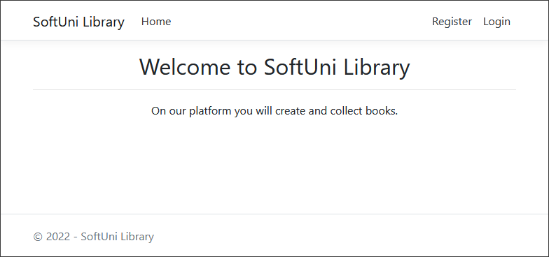

### Login Page (logged-out user)

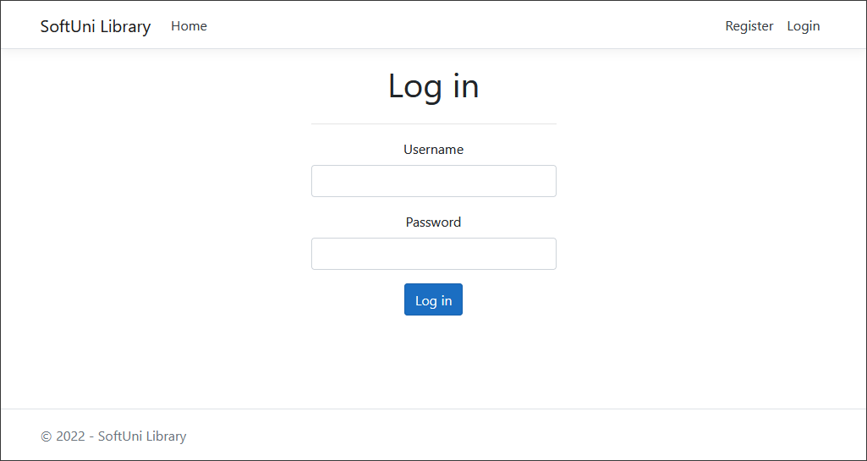

### Register Page (logged-out user)

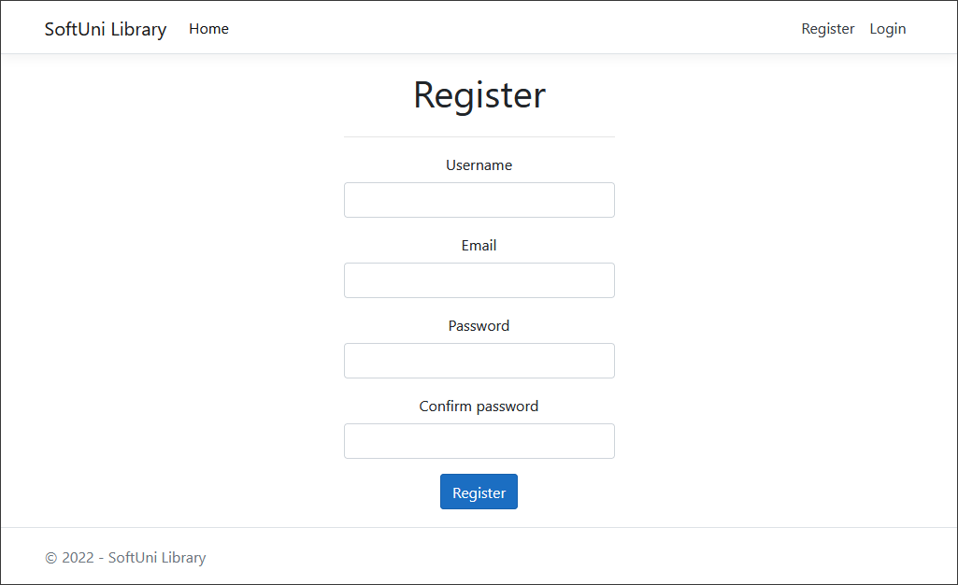

### /Books/All (logged-in user)

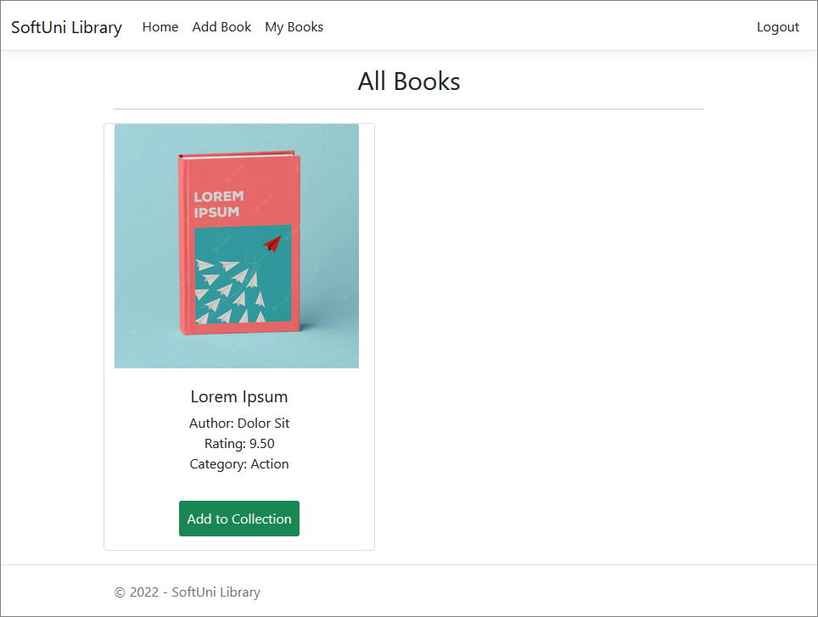

**NOTE**: If the user is logged in and tries to go to the **Home page**, the application must redirect them to the **/Books/All**.

### /Books/Mine (logged-in user)

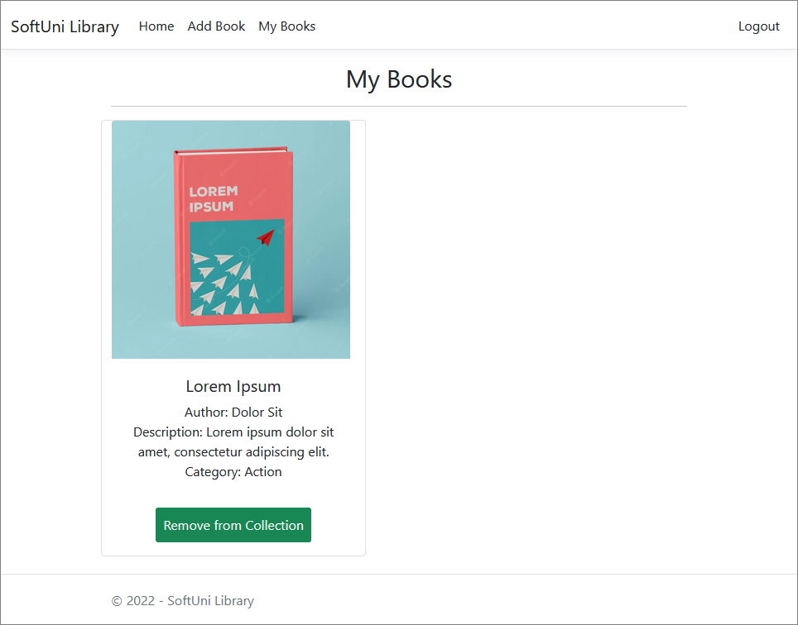

### /Books/Add (logged-in user)

### /Books/AddToCollection?bookId={bookId} (logged-in user)

Adds the selected book to the user's collection of books. If the book is already in their collection, it shouldn't be added. If everything is successful, the user must be redirected to the home "**/Books/All**" page.

### /Books/RemoveFromCollection?bookId={bookId} (logged-in user)

Removes the selected book from the user's collection of books. If everything is successful, the user must be redirected to their collection "**/Books/Mine**" page.

**NOTE**: The templates should look **EXACTLY** as shown above.

## Functionality

The functionality of the **BookLibrary** Platform is very simple.

### Users

Guests can Register, Login and view the Index Page.

Users can AddBooks and see added Books by all Users on the Home Page (/Books/All). From the Home Page (/Books/All),they can also view Info about each one of those Books and Add them to their collection.

### Books

Books can be Added by Users. All created Books are visualized on the Home Page (/Books/All), each one in its separate rectangular element.

Books are visualized on the Home Page (/Books/All) with all their information.

Books are visualized on the Home Page (/Books/All) with a button – [**Add to Collection**].

* The [**Add to Collection**] button adds the Book to the User's collection of Books, **unless it is already added**.

Usershave a My Books page where only the Booksin their collection are visualized.

* The [**Remove from Collection**] button removes the Book from the User's collection of Books.

### Redirections

* Upon successful Registration of a User, you should be redirected to the Login Page.
* Upon successful Login of a User, you should be redirected to the /Books/All.
* Upon successful Creation of a Book, you should be redirected to the /Books/All.
* Upon successful Adding a Book to the User's collection, should be redirected to the /Books/All.
* Upon successful Removal of a Bookfrom the User's collection, should be redirected to the /Books/Mine.
* If a User tries to **add** an **already added** Book to their **collection**, they should be redirected to /Books/All (or just a page refresh).
* Upon successful Logout of a User, you should be redirected to the Index Page.
* If any of the **validations** in the POST forms **don't pass**, **redirect** to the **same page** (**reload/refresh** it).

## Security

The Security section mainly describes access requirements. Configurations about which users can access specific functionalities and pages:

* Guest (not logged in) users can access the Index page.
* Guest (not logged in) users can access the Login page.
* Guest (not logged in) users can access the Register page.
* Guests (not logged in) cannot access Users-only pages.
* Users (logged in) cannot access Guest pages.
* Users (logged in) can access the Books/Add page and functionality.
* Users (logged in) can access the Books/All page.
* Users (logged in) can access the **My** Books page.
* Users (logged in) can access Logout functionality.

## Code Quality

Make sure you provide the best architecture possible. Structure your code into different classes, follow the principles of high-quality code (**SOLID**). You will be scored for the Code Quality and Architecture of your project.

## Scoring

### Database Requirements – 10 points.

### Template Requirements – 10 points.

### Functionality – 50 points.

### Security – 10 points.

### Code Quality – 10 points.

### Data Validation – 10 points.